50 Years of the Cauchy Problem for Einstein’s Equations
Cargese, 28th July – 9th August 2002

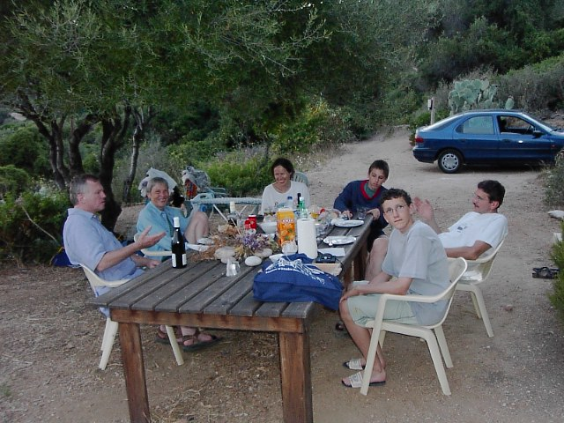

It’s hard work being an organizer
(Piotr and Helmut discuss tomorrow’s schedule)
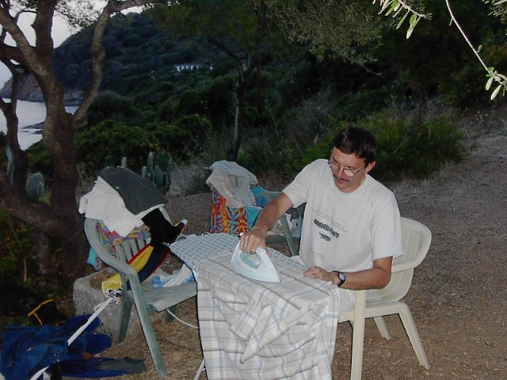

Piotr takes in ironing in order to balance the conference budget

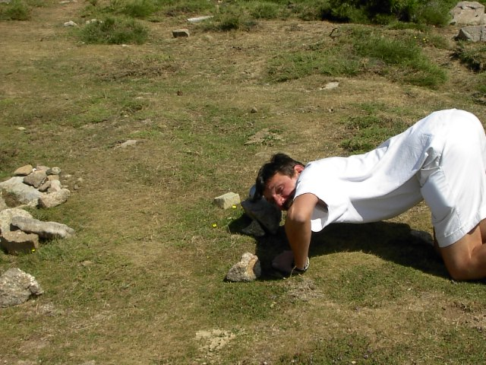

Organisers leave no stone unturned in their search for funds
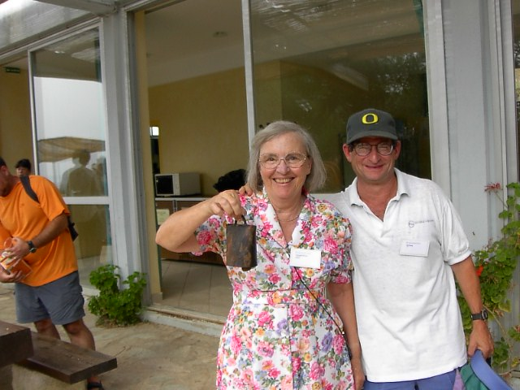

And all the session organizers have to do is to ring the bell
(Yvonne Choquet-Bruhat with Jim Isenberg)

While some participants get down to serious work,
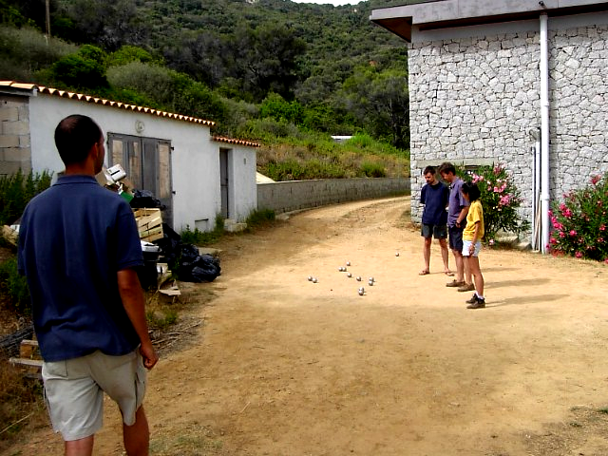
others concentrate on problems of a different nature.

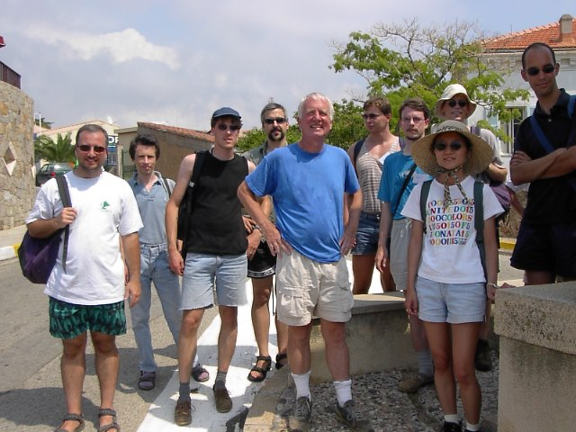

Intrepid adventurers set out, buoyed with optimism,

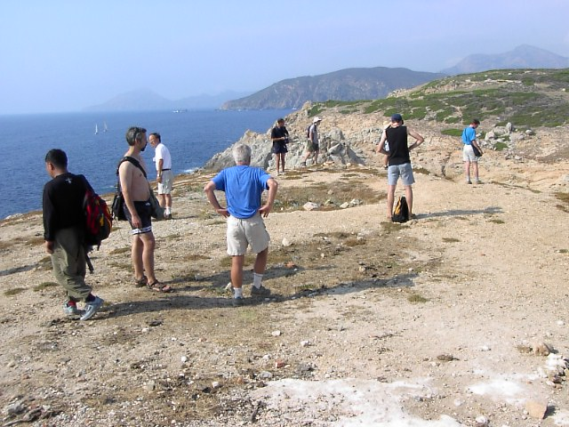

but existential despair sets in
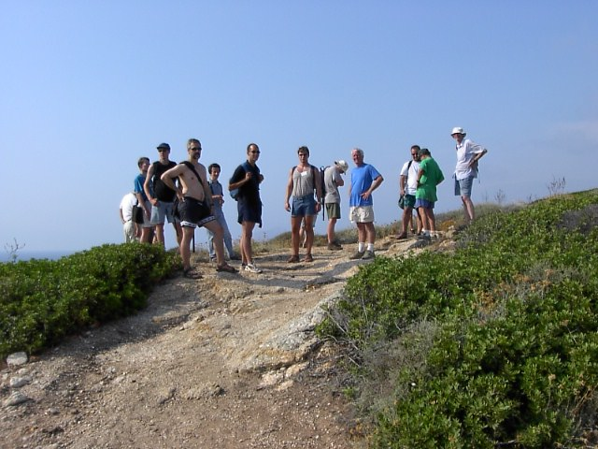

before finally the true path is found.

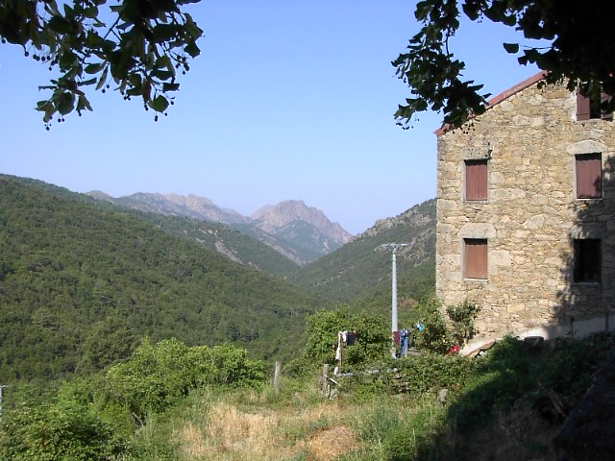

The mountains are beautiful
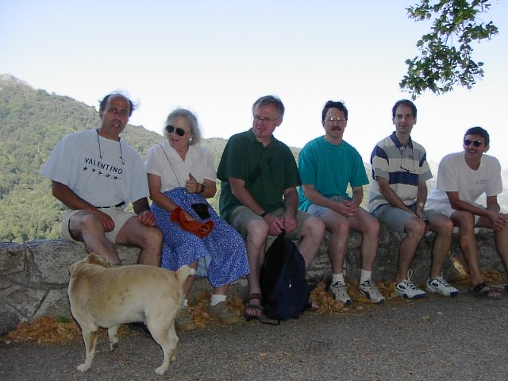

but a dog bites Bobby’s foot.

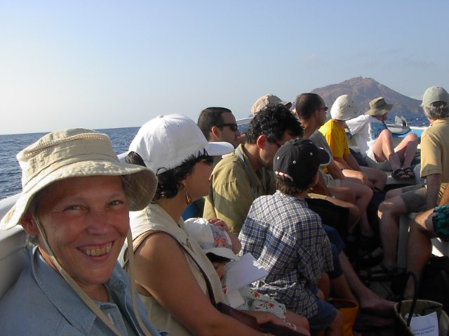

Nobody was seasick (much)

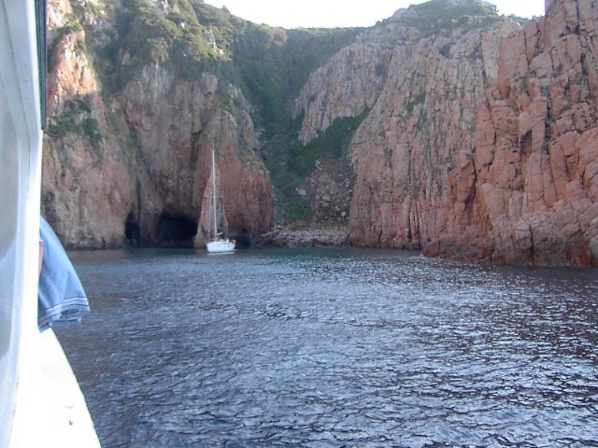

except the poor souls on this yacht, when they realized the class of
riff-raff which had arrived, uninvited, to share their peaceful calanque.

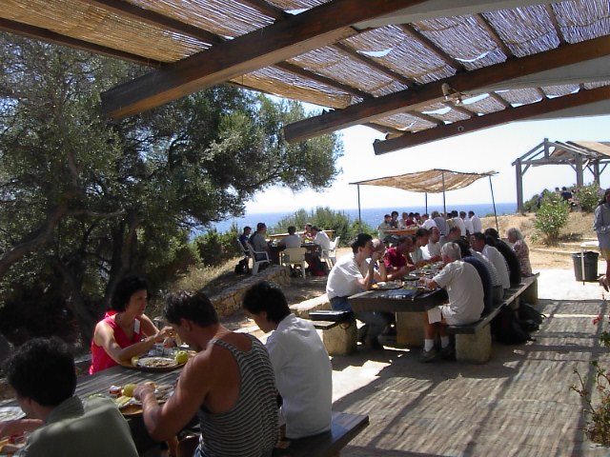
Lunch is very important

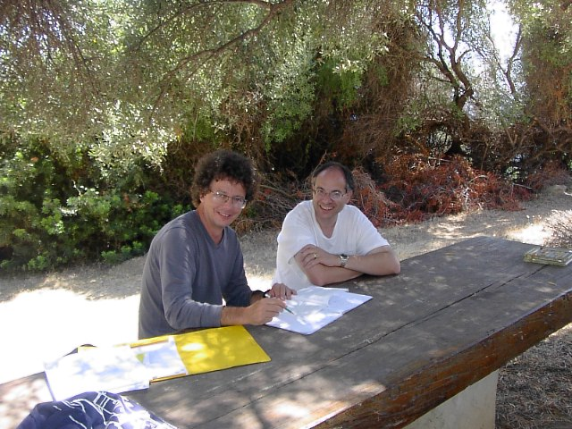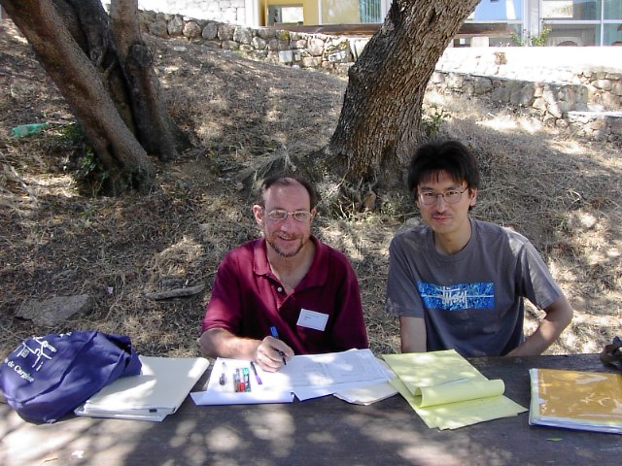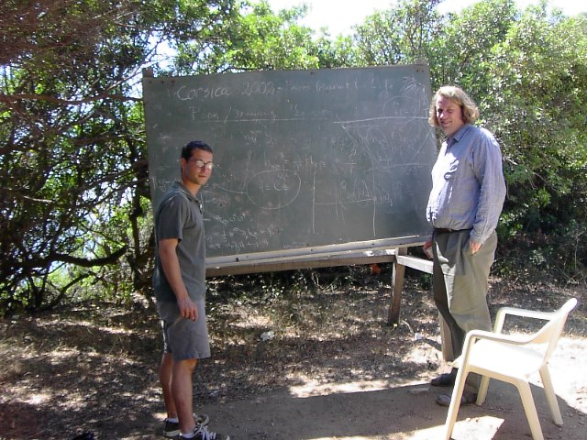

and after lunch, back to work…..

